BRANCH REPORT

ON45 | Quinte

President’s message
It’s the start of the New Year as I prepare this spring report. I’m sure you can agree 2019 just flew by.
This year’s branch annual general meeting (AGM) will be held on Tuesday, April 21 at Belleville’s The Banquet Centre located at 1 Alhambra Square in the Emerald Room, which is in the lower level and is accessible by ramp. Doors open at 11:30 am with lunch served around noon. There is no cost for members and only $10 for non-members. RSVP by April 13 by email (preferred) or by phone to the branch (fsnaon45@gmail.com / 613-968-7212). Arrangements are being made to have Jill Mills from HearingLife return. The business portion covers 2019 reports from the president and treasurer and there are elections. This brings me to solicit your interest in volunteering as we require a webmaster and members for the phone committee.
As in the past, the branch is covering the transportation costs to and from the luncheon for those Belleville residents who would otherwise not be able to attend. Please call Bluebird Taxi at 613-969-9676 to arrange your ride. Show your membership card and the cost will be charged to our account.

Have you wondered how many members our branch has? Well, as of January 6th, the totals are:
Members: 885
Double Memberships: 279
Single Memberships: 327
Non DDS Memberships: 114
DDS Memberships: 492

I will be attending the Ontario District Meeting in Toronto scheduled April 28 to 30. Ontario has 22 branches and two Directors, Linda MacDonald and Ted Young. At this time the agenda has not been released but if we receive anything like last year’s information and training, it will be very productive.

From June 9 to 11, I will be at the Annual Members Meeting in Gatineau. This is when representatives from all 79 branches across Canada gather. Presentations, approvals, elections, discussion groups, training and volunteer recognition is all packed in over just a few days.

Something else I want to share is that the branch’s 2019 Christmas luncheon did not occur; it had to be cancelled, due to insufficient numbers. For many of the dedicated members who attend this event, this was very sad.

Joan, Rockburne
President
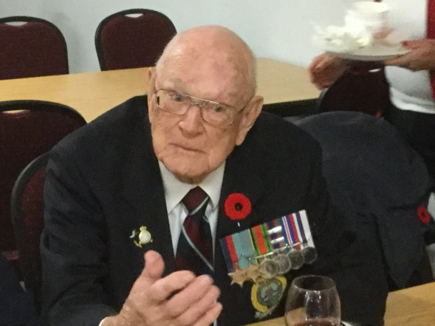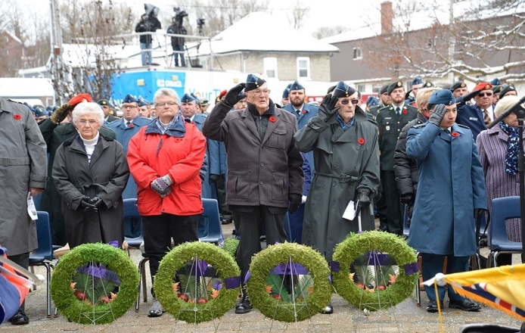

We are honoured that Bill Robertson represented our branch at November 11, 2019 ceremony at the Belleville Cenotaph. Branch Vice-President Kathy Nisbet accompanied him throughout the day.

The pictures above are Bill at the Royal Canadian Legion reception afterwards and at the Cenotaph.

The following is the write-up sent to National Office to report what our branch did, with the hope it would be featured in the SAGE Magazine.

Remembrance Day 2019 – Quinte Branch

The Quinte Branch partnered with the Royal Canadian Legion Branch #99 Belleville, participating in the November 11th activities.

The wreath was laid by 2nd World War Veteran, William A. “Bill” Robertson, who at 98 years young, was honoured that he was asked. In March 1942, on his 12th operational flight as a bomb aimer, from a raid on Hasselt, Belgium, the plane was shot down and Bill landed in a field. He believes after hiding for about 18 hours, he approached a couple of young boys identifying himself as Royal Air Force, but they ran off. Their uncle returned, bringing farmer coveralls to cover up his uniform. Later he was interviewed by the Belgium Resistance Underground to determine if he was a genuine ally airman or whether an infiltrator. Bill passed and was given wooden clogs, as flying boots would be a dead giveaway that he was a pilot. He was also given a false Belgian ID card in the name of Georges Arthur Vanstraeten, while he was in hiding in Liege, Belgium.

Additionally, the Quinte Branch posted to their Facebook page a message linking it to a video created and written by Jerry Meyer entitled “Remembering Their Sacrifices…Lest We Forget”.

Finally, a “3x3” Remembrance Day ad was placed in the CFB Trenton Contact Newspaper.

