BRANCH **REPORT**

ON35 | HURONIA

# President’s message

Bonjour to everyone. At our Branch AMM held May 1, 2024 we said goodbye to three longtime volunteers; Dianne Michals, Jackie Akeson, and Lynne Ellis. We thank them for their many years of service. Fortunately, we were able to welcome two new volunteers, Julia Nicholls and Manon Auger.

Kathy Rupnow, Branch Director Recruitment, attended a Volunteer Fair on May 11, 2024 at the Barrie Public Library.

Leo Brooks and I attended a “My Transition Seminar” held at CFB Borden’s Officer’s Mess on May 28-29, 2024. These seminars are an updated SCAN seminar and we were very happy to participate and provide information to potential new NAFR members.

Leo Brooks, Director Advocacy, remains active with the Senior Housing Alliance – Simcoe County, advocating for senior housing and alternatives to Long-Term Care Facilities and Nursing Homes.

The Branch AGM will be on October 9, 2024 at the Barrie Legion and the guest speakers will be Nina Cabral and Jeremy Bertrand, both from the Ontario Ministry of Finance.

As you can see, your Branch Board is active and here to serve you.

Contact Us

80 Bradford Street

Barrie, Ontario

L4N 6S7

1-905-806-1954

huronia@federalretirees.ca

[Huronia Federal Retirees](https://www.federalretirees.ca/en/branches/ontario/huronia-branch)

Membership

Single memberships are $55.92 per year and double memberships are $72.60 per year.

Members are encouraged to pay membership dues through Dues Deduction at Source (DDS). It is the simplest and most convenient way to pay for your membership and to automatically renew annually. Thanks to our relationship with Treasury Board and the Pension Centre, the DDS option allows your membership fees to be deducted directly from your pension on a monthly basis.

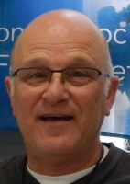

Sincerely,

Chris Auger

Huronia Branch President



# Huronia Branch Annual Meeting of Members – May 1, 2024

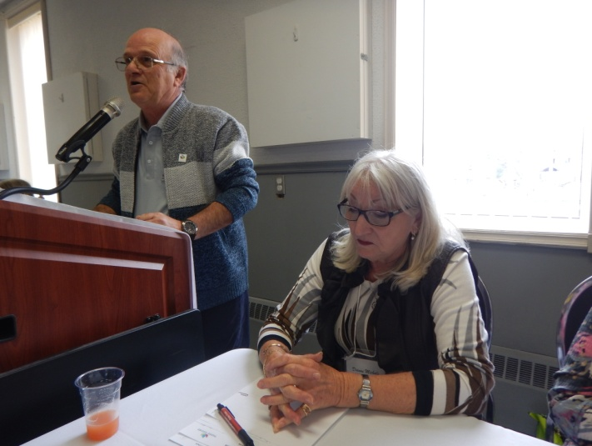The Huronia Branch Annual Meeting of Members (AMM) was held at the Barrie Legion.

Two of our Board members did not run for re-election. After a run of 6 years, Dianne Michals resigned as Secretary. Jackie Akeson also resigned after having served on the Board for twelve years, formerly as the Director of Health and Benefits, and most recently as a Director at Large. Lynne Ellis completed her one year as Past President and has also resigned from the Board, after having served on the Board since 1997.

*Chris Auger (President) and Dianne Michals (secretary)*

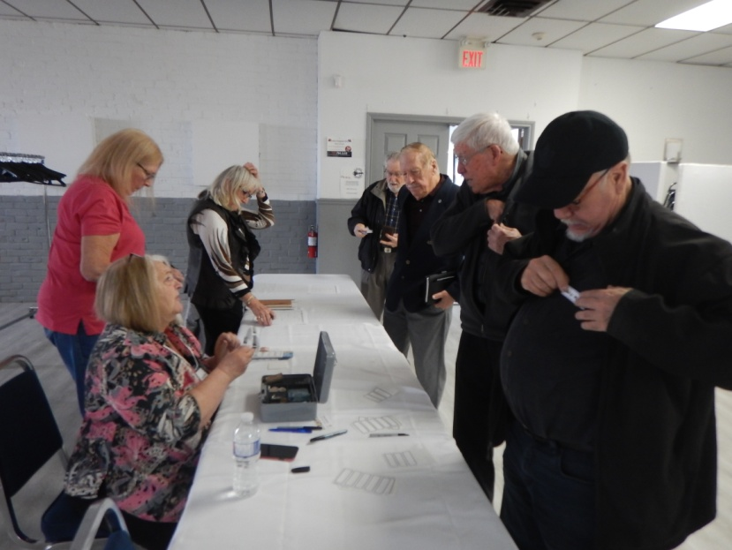We have two new members on the Board. Julia Nichols has agreed to replace Noreen Campbell as Treasurer after a suitable training and transition period. Noreen has agreed to stay on as a Director at Large.

Our second volunteer is Manon Auger, who agreed to join as a Director at Large.

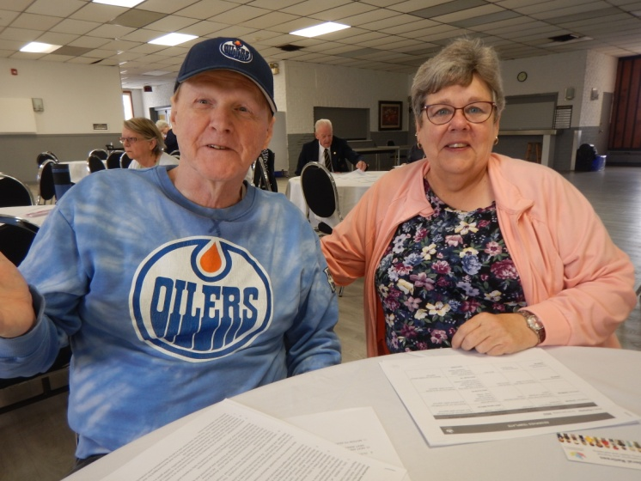Our President, Chris Auger will be filling in as Secretary until such time as a new volunteer steps forward. Currently with only seven Board members, and a couple of Board members filling multiple roles, it is becoming critical to the sustainability of the Branch, that other Branch members join the Board. Monthly Board meetings are zoom meetings, so the only required travel is to the spring AMM and Fall AGM, both held in Barrie.

Our speaker at the AMM was Maren Drisch, Affinity Marketing Manager with HearingLife Canada, one of the NAFR Preferred Partners. The presentation was very informative, not only providing a detailed explanation of the inner workings of the ear, but also the benefits offered to members, such as hearing aid discounts and four years of complimentary hearing aid battery coverage. More details are available on the NAFR website under Privileged Partners/Health Partners/HearingLife.

*Ron and Elizabeth Williamson*

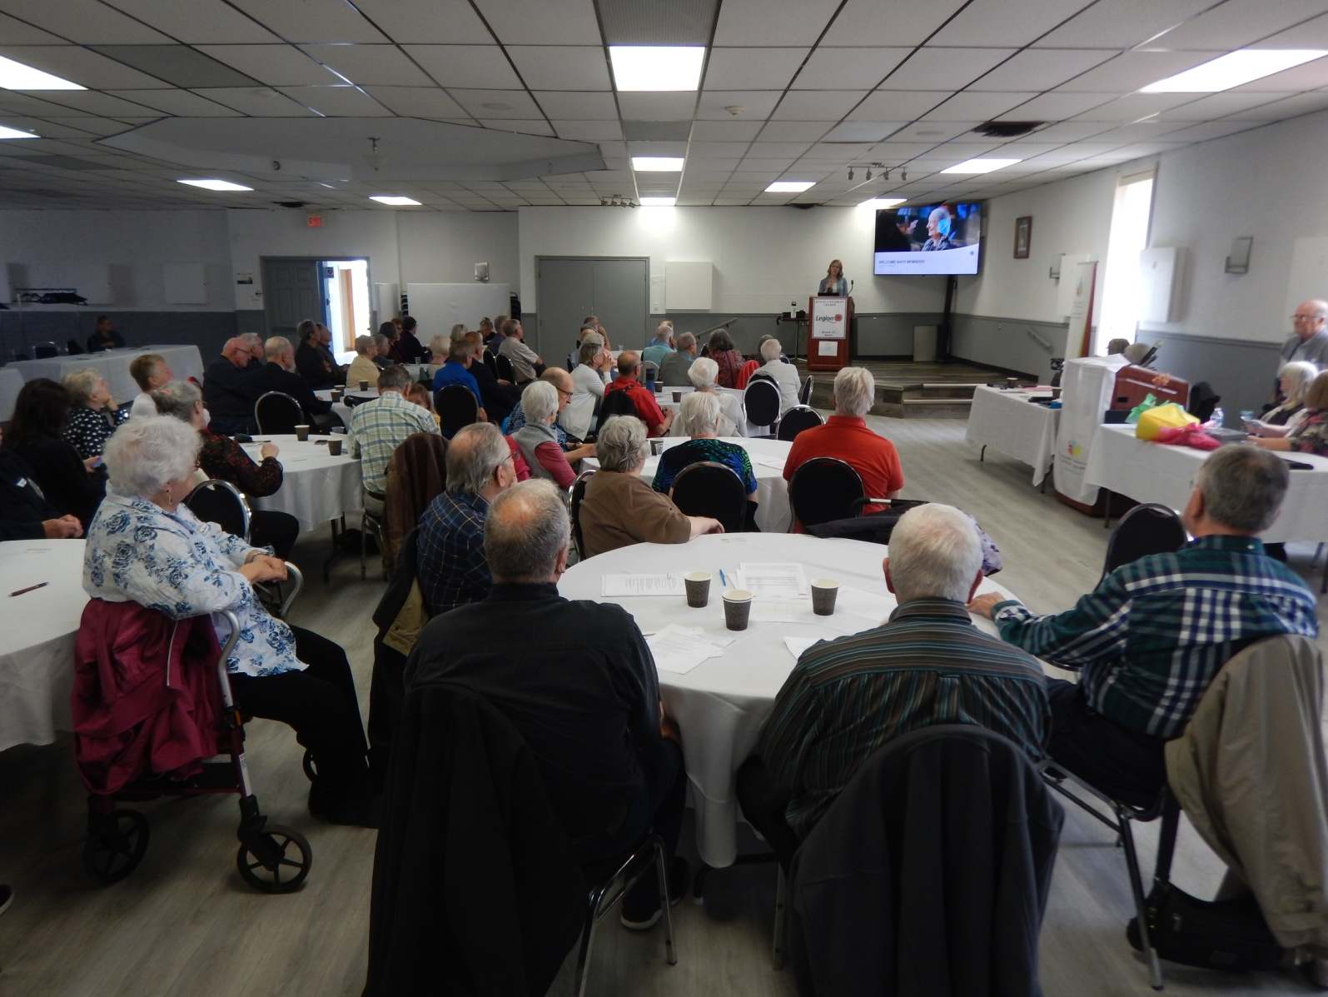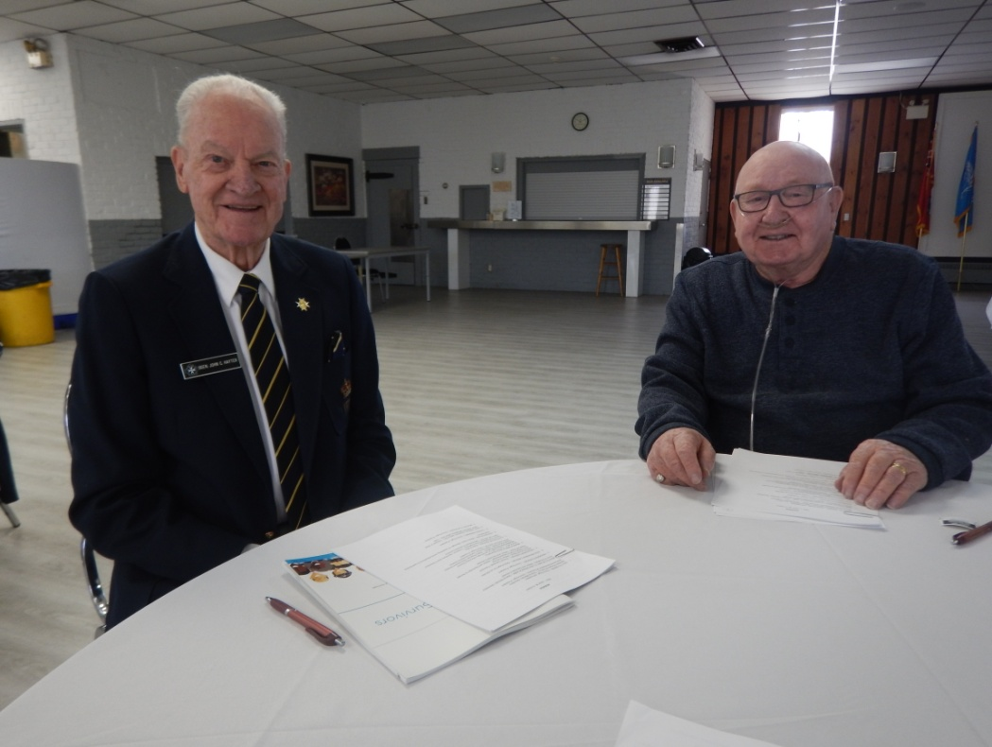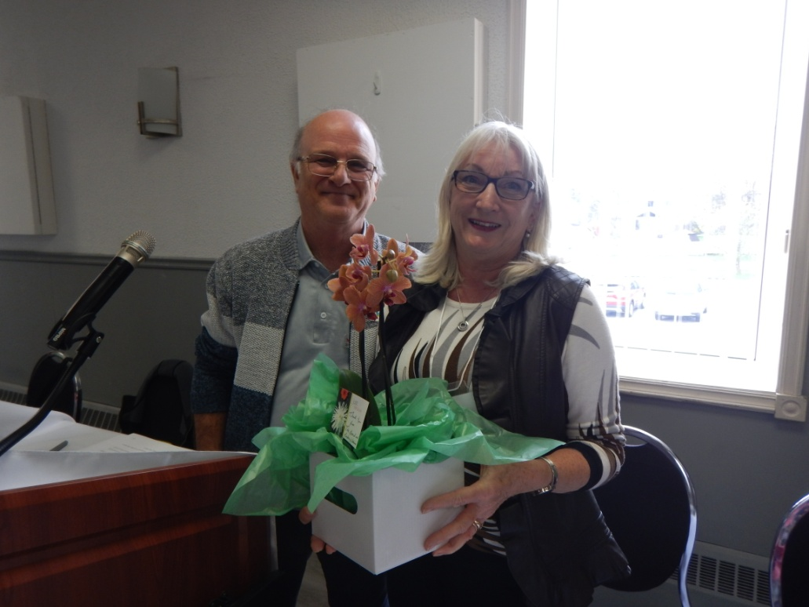

*Guest speaker Maren Drisch, addressing the attendees at the Huronia Branch AMM.*

*BGen (Ret’d) John Hayter and Detlef Frerichs*

*President Chris Auger presenting Dianne Michals with a parting gift.*

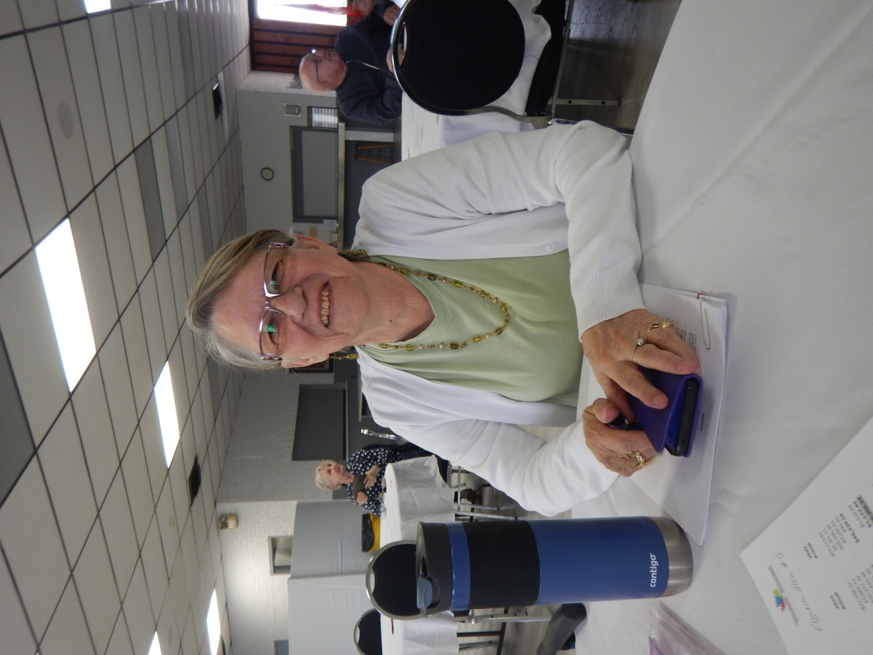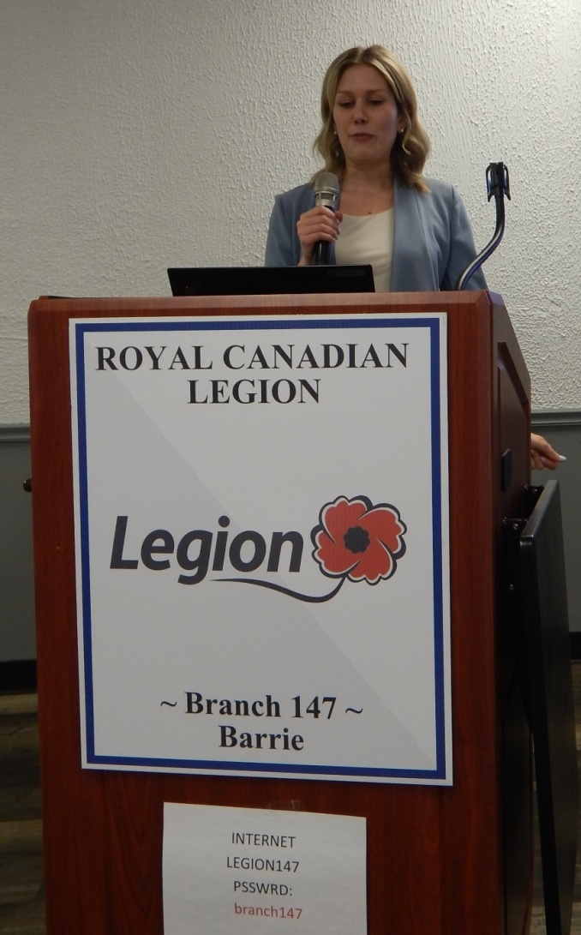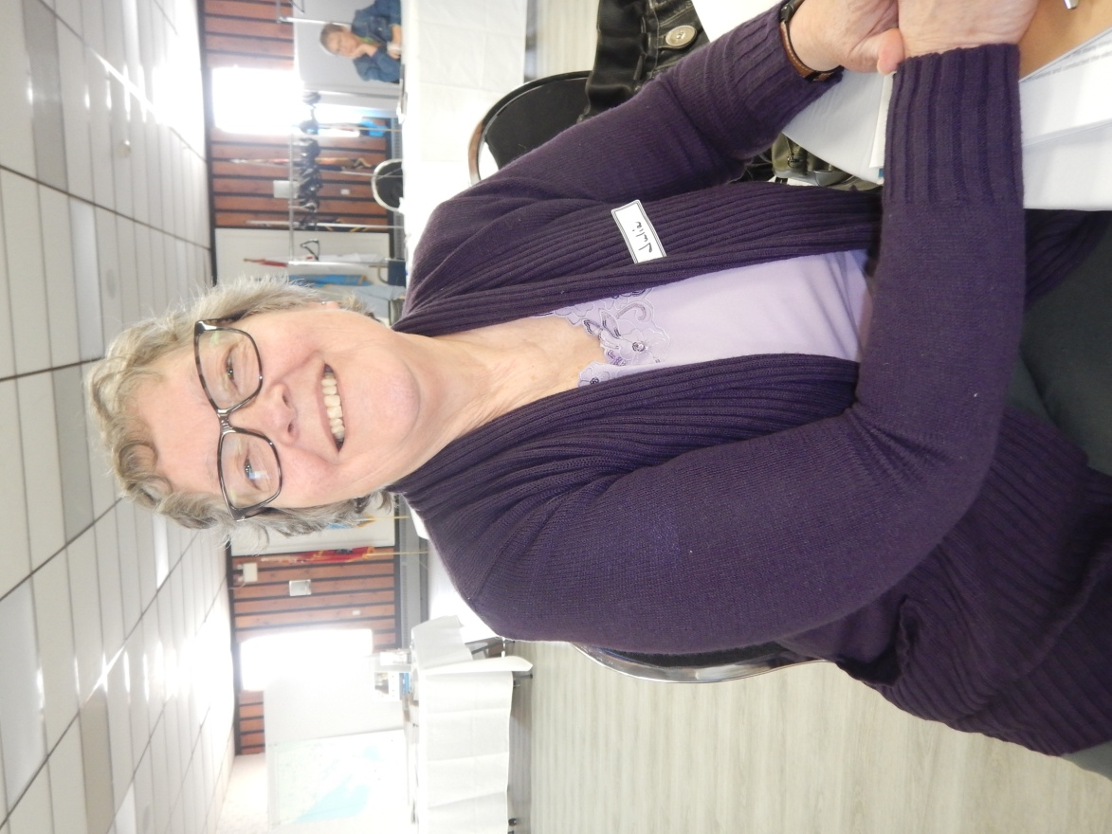

*Guest speaker Maren Drisch*

*Manon Auger*

*Julia Nicholls*

Upcoming events

Huronia Branch AGM

Wednesday, Oct 9, 2024

**Doors open at 10:30 a.m. Meeting 11 a.m. until 1 p.m.**

Royal Canadian Legion, 410 St. Vincent Street, Barrie, Ontario

$7 for lunch

RSVP to confirm attendance and lunch:

huronia@federalretirees.ca

**Guest Speakers:**  Nina Cabral and Jeremy Bertrand from Ontario Ministry of Finance.

**Topic:** Ontario’s Medical Expense and Senior’s Care at Home Tax Credit.

Communications: Mark Burchell

mark_burchell@sympatico.ca

Web Editor: Chris Auger

cauger291@gmail.com

Recruitment: Kathy Rupnow

on35.recruitment@gmail.com

Director at Large: Manon Auger

augerm201@gmail.com

Contact us

huronia@federalretirees.ca

Huronia Federal Retirees

National association of federal retirees

# Board and Volunteer Listings 2024-2025

President: Chris Auger

cauger291@gmail.com

Vice President: Leo Brooks

leo.brooks@rogers.com

Secretary: Vacant

Treasurer: Noreen Campbell

on35.treasurer@gmail.com

**Treasurer-in-Training**: Julia Nicholls

nichollsjuliaa@gmail.com

Advocacy: Leo Brooks

leo.brooks@rogers.com

*Julia Nichols*