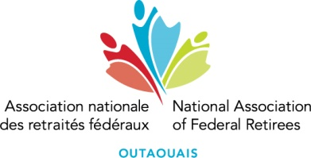**Nomination and Director’s Elections**

**33rd Annual General Meeting**

**Wednesday, April 9th, 2025**

The Outaouais Branch’s Board of Directors has established a Nomination Committee for the 2025 Annual General Meeting (AGM) to be held on **Wednesday April 9th, 2025, from 09:30 a.m. to 12:30 p.m. at the Cabane en bois rond, Desjardins room, located at 115-331 Boul. de la Cité-des-Jeunes in Gatineau.**

The Board is comprised of eleven (11) directorships and pursuant to our bylaws, a director is usually elected to the AGM for a two (2) year term. To allow continuity of the Board, six (6) positions are usually subject to election in even years.

The outgoing Board currently consists of eleven (11) directors, of which five (5) director positions will be filled at the 2025 AGM.

For an overview of the qualities sought to become an administrator, please see the "**Qualities and Functions of Directors"** document available on our [**web page**](https://www.federalretirees.ca/en/branches/quebec/outaouais-branch/annual-general-meeting/2025).

On behalf of the Chair of the Nominations Committee, I invite you to apply for a position on the Board of Directors. To do so, please complete the **"Nomination Form"** available on our [**web page**](https://www.federalretirees.ca/en/branches/quebec/outaouais-branch/annual-general-meeting/2025) and send it to the President of Elections at [aga@anrf-outaouais.ca](mailto:aga@anrf-outaouais.ca) .

Sincerely yours,

Réal Fortin, President of the Outaouais Branch