BRANCH REPORT

ON45 | Quinte

President’s message
Merry Christmas and Happy New Year!
The fall was a busy time for the branch. For the federal election, the branch held an all-candidates meet and greet on September 10th. Please see page 2 and 3 for more details and pictures.
Veterans’ Week was from November 5-11 recognizing the 75th anniversary of the Second World War’s Italian campaign. The branch once again supported the Royal Canadian Legion Branch #99 on November 11.
The annual Christmas luncheon was held November 26th at the Banquet Centre. A good crowd attended and the meal was delicious.
A couple of important 2020 branch events you should plan on attending: April 21, 2020 for the Branch’s Annual General Meeting (AGM) and November 24, 2020 for the Christmas luncheon.
The new version of the “You and Your Survivors” brochure is being developed and will be online by the end of 2019 and a printed version available in January 2020.
A reminder the annual membership fees will be increased by the Indexed Rate applied to members’ pension in the previous year, adjusted to be evenly divisible by 12.

Contact Us
PO Box 20074
Belleville ON
K8N 5V1
613-968-7212

fsnaon45@gmail.com

www.federalretirees.ca/quinte

Membership
The National Association of Federal Retirees, or commonly Federal Retirees, is the largest national advocacy organization representing active and retired members of the federal public service, Canadian Armed Forces, Royal Canadian Mounted Police (RCMP) and retired federally appointed judges, as well as their partners and survivors.

We believe every Canadian, today and in the future, should benefit from better retirement income security and a strong, sustainable health care system.

With your support, we can make retirement better for all Canadians

Sincerely,
Joan Rockburne
Branch President

Federal Election Candidates Meet & Greet
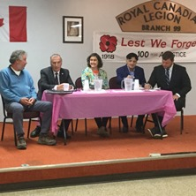
On September 10, 2019 the Quinte Branch hosted an all-candidates meet and greet for the Bay of Quinte riding at the Belleville Royal Canadian Legion. We received support from the Canadian Association of Retired Person (CARP) and the Association’s Quintrent Branch.
L to R: Danny Celovsky (Green), Neil Ellis (Liberal),
Stephanie Bell (NDP), Paul Bordanaro (Peoples) and Tim Durkin (Conservative)

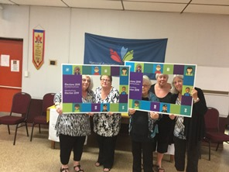
About 120 to 150 people heard five-minute presentations from candidates Stephanie Bell of the NDP, Paul Bordanaro of the People’s Party, Danny Celovsky of the Green Party, Tim Durkin of the Conservatives and Neil Ellis of the Liberal. The candidates then mingled with the public afterwards giving those in attendance a chance to ask specific questions or just meet the candidates.

This event occurred the day before the writ was dropped so a number of the parties had not released their platforms. Regardless, the candidates did touch on at least some of the major concerns raised by the Federal Retirees.

Attending the event were Belleville Mayor Mitch Panciuk, and Quinte West Counsellor Terry Cassidy. We wish to extend our thanks to Bev Buchanan and Louise Warr and the members of of CARP Greater Bay of Quinte Area Chapter 39; to InQuinte for the media coverage, notably Bill Glisky; to our National Office Advocacy Team for their support; to our branch members, especially the volunteers, and last, but not least, to the five candidates for making this event the success it was.
Quinte Branch Volunteers (L to R): Pat Russell, Rose Doran, Dianne Raniowski, Joan Rockburne and Kathy Nisbet

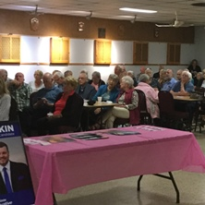
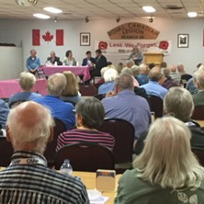

Above right: Candidates and Pat Russell at the podium, opening the event.
Above left: Some of the audience.
Below left: Bev Buchanan of CARP, Pat Russell and Dianne Raniowsk.
Below right: Belleville Mayor Mitch Pancuik speaking to an attendee.

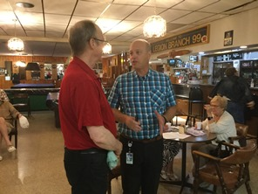
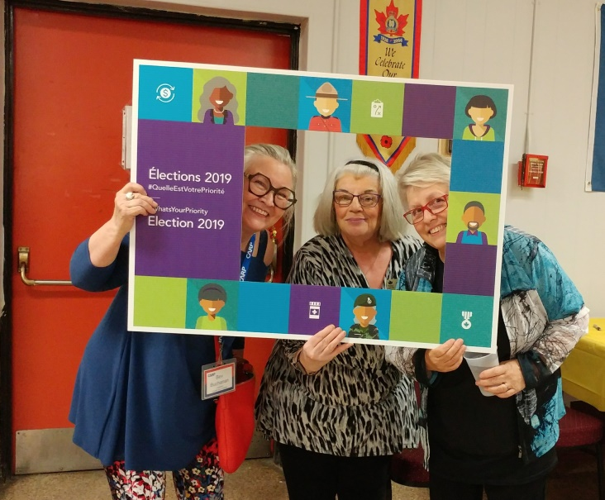

Subhead
Caption to go here

Subhead
Caption to go here

Subhead
Caption to go here

National association of federal retirees

Board and Volunteer Listings
2019-2020
Upcoming events
2020 Annual General Meeting (AGM)
Tuesday, April 21, 2020
Watch for e-blast/check branch website for details

2020 Christmas Luncheon
Tuesday, November 24, 2020

Reminder
The Branch is open every 2nd and 4th Tuesday of the month from 1:00 to 3:00 pm, with exception of July and August when we are closed for the summer. As always, telephone and email are regularly monitored.

President: Joan Rockburne
Vice-President: Kathy Nisbet
Treasurer: Pat Russell
Secretary: Sharon Brohm
Membership/Social: Dianne Raniowski
Director: Nancy Landry
Health Benefits Officer: Ken Capstick

Contact us
National Association of Federal Retirees
Quinte Branch
PO Box 20074, Belleville, ON K8N 5V1

Association website: www.federalretirees.ca
Quinte Branch website:
www.federalretirees.ca/quinte

